Transformation About an Axis

Definition
# Source: AI Source: Provided by: [Data Path: Persons Table -> ID Column: 1, Name_En Column: Motasem Essam] -> From: [ChatGPT] on [7/25/2026]
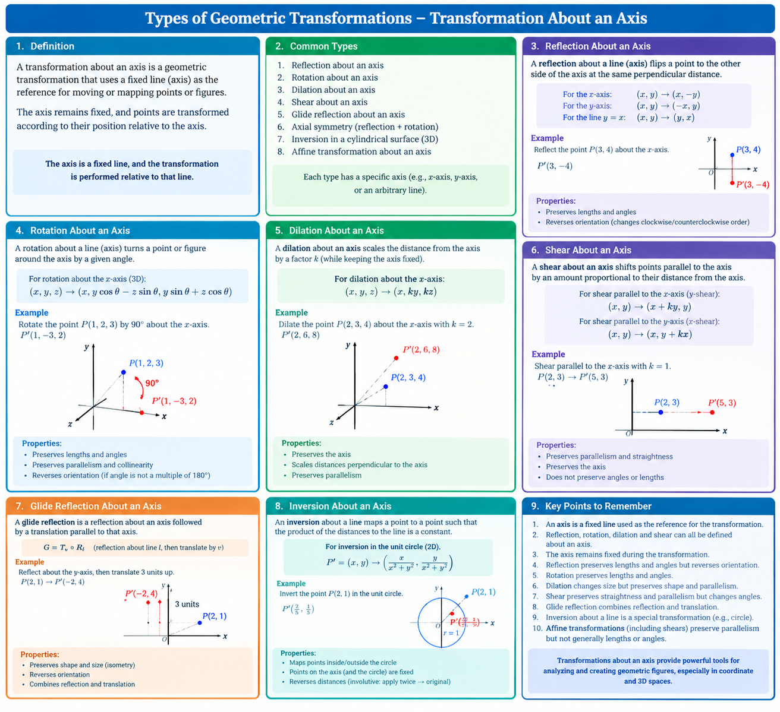
A Transformation About an Axis is a geometric transformation defined relative to a fixed line called the axis of transformation. The axis serves as a reference for reflecting, rotating, or otherwise mapping points and figures.
The exact meaning depends on the transformation:
- Reflection across an axis: maps points to mirror-image positions on opposite sides of a line.
- Rotation about an axis: turns points around a fixed line, typically in three-dimensional space.
- Axial symmetry: describes a figure that remains unchanged when reflected across an axis.

Simple Definition
# Source: AI Source: Provided by: [Data Path: Persons Table -> ID Column: 1, Name_En Column: Motasem Essam] -> From: [ChatGPT] on [7/25/2026]
A transformation about an axis is a geometric transformation that uses a fixed line as its reference.
Important distinction: In plane geometry, an axis commonly means a reflection line. In three-dimensional geometry, an axis can also be the line around which an object rotates.

Main Classification
# Source: AI Source: Provided by: [Data Path: Persons Table -> ID Column: 1, Name_En Column: Motasem Essam] -> From: [ChatGPT] on [7/25/2026]
A practical classification is:
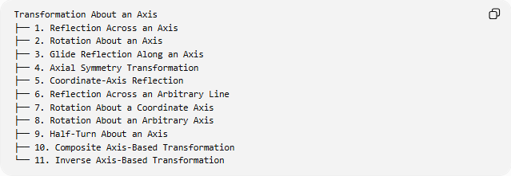
Transformation About an Axis
├── 1. Reflection Across an Axis
├── 2. Rotation About an Axis
├── 3. Glide Reflection Along an Axis
├── 4. Axial Symmetry Transformation
├── 5. Coordinate-Axis Reflection
├── 6. Reflection Across an Arbitrary Line
├── 7. Rotation About a Coordinate Axis
├── 8. Rotation About an Arbitrary Axis
├── 9. Half-Turn About an Axis
├── 10. Composite Axis-Based Transformation
└── 11. Inverse Axis-Based Transformation
These categories describe different operations or settings; they are not all mutually exclusive. For example, reflection across a coordinate axis is a special case of reflection across an axis.

Reflection Across an Axis
# Source: AI Source: Provided by: [Data Path: Persons Table -> ID Column: 1, Name_En Column: Motasem Essam] -> From: [ChatGPT] on [7/25/2026]
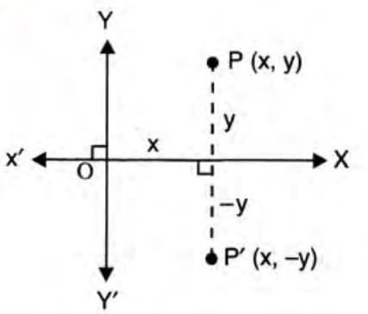
Definition: Reflection across an axis maps every point to its mirror-image position on the opposite side of a line, at the same perpendicular distance from that line.
For reflection across the $x$-axis:
$$\boxed{\left(x , y\right)→\left(x , -y\right)}$$
For reflection across the $y$-axis:
$$\boxed{\left(x , y\right)→\left(- , xy\right)}$$
For reflection across $y=x$:
$$\boxed{\left(x , y\right)→\left(y , x\right)}$$
Example: Reflect $P=\left(3 , 4\right)$across the $x$-axis.
$$P^{'}=\left(3 , -4\right)$$
Properties:
- Preserves lengths and angle measures.
- Preserves collinearity and parallelism.
- Reverses orientation.
- Is self-inverse: applying the same reflection twice restores the original figure.

Rotation About an Axis
# Source: AI Source: Provided by: [Data Path: Persons Table -> ID Column: 1, Name_En Column: Motasem Essam] -> From: [ChatGPT] on [7/25/2026]
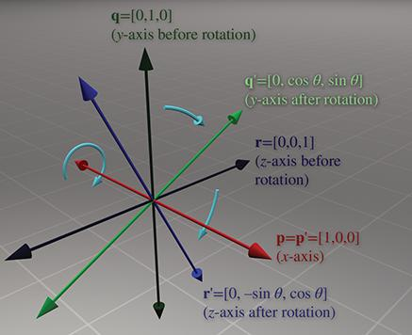
Definition: Rotation about an axis turns a point or three-dimensional figure around a fixed line by an angle $θ$.
Rotation about an axis is primarily a three-dimensional transformation. For rotation about the $x$-axis:
$$\boxed{\begin{aligned}x^{'}&=x \\ y^{'}&=y\cos{θ}-z\sin{θ} \\ z^{'}&=y\sin{θ}+z\cos{θ}\end{aligned}}$$
Example: Rotate $P=\left(1 , 2 , 3\right)$by ${90}^{∘}$about the $x$-axis.
$$\left(x , y , z\right)→\left(x , - , zy\right)$$
Therefore:
$$\boxed{P^{'}=\left(1 , - , 32\right)}$$
Properties:
- Keeps points on the rotation axis fixed.
- Preserves distances and angles.
- Preserves shape and volume.
- Reversing the angle reverses the rotation.

Dilation About an Axis
# Source: AI Source: Provided by: [Data Path: Persons Table -> ID Column: 1, Name_En Column: Motasem Essam] -> From: [ChatGPT] on [7/25/2026]
Definition: A dilation about an axis scales the perpendicular distance from each point to the axis while keeping points on the axis fixed. This is a useful descriptive model for axis-based scaling in three dimensions.
For the $x$-axis, one example is:
$$\boxed{\left(x , y , z\right)→\left(x , k , ykz\right)}$$
where $k$is a scale factor.
Example: Let $P=\left(2 , 3 , 4\right)$and $k=2$.
$$\left(2 , 3 , 4\right)→\left(2 , 6 , 8\right)$$
Properties:
- Points on the $x$-axis remain fixed.
- Distances perpendicular to the axis are multiplied by $∣k∣$.
- Parallelism is preserved.
- General lengths and angles need not be preserved.
This is not the same as uniform dilation about a point, which scales distances in all directions from that point.

Shear Relative to an Axis
# Source: AI Source: Provided by: [Data Path: Persons Table -> ID Column: 1, Name_En Column: Motasem Essam] -> From: [ChatGPT] on [7/25/2026]
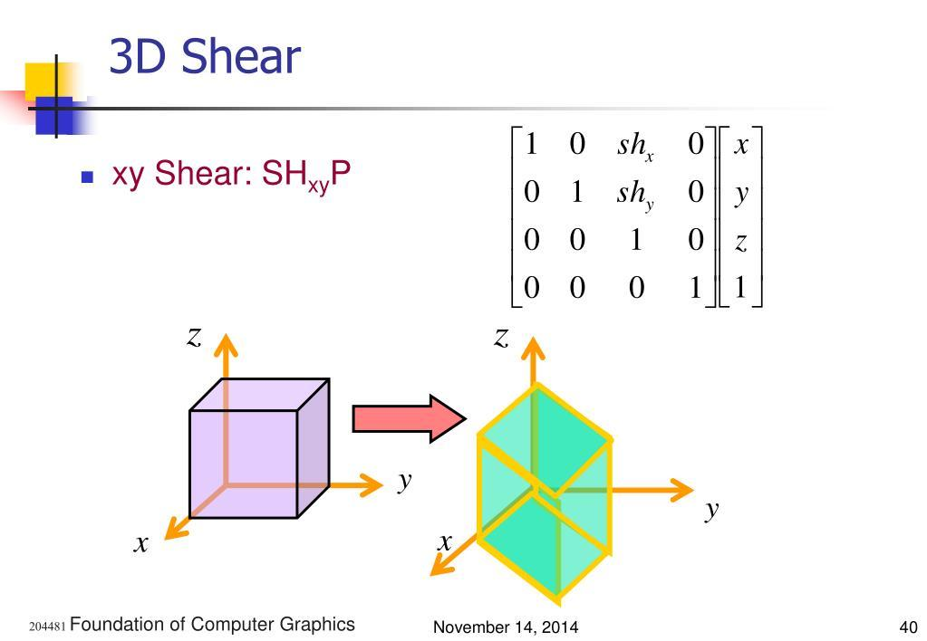
Definition: A shear relative to an axis shifts points in a direction parallel to that axis, with the displacement depending on their position.
For a two-dimensional horizontal shear:
$$\boxed{\left(x , y\right)→\left(x , +kyy\right)}$$
Example: If $k=2$and $P=\left(3 , 4\right)$:
$$P^{'}=\left(3 , +2\left(4\right)4\right)$$
$$\boxed{P^{'}=\left(11 , 4\right)}$$
Properties:
- Preserves straightness and parallelism.
- Generally changes lengths and angles.
- Unlike reflection, it does not produce a mirror image.
- The precise axis-relative shear rule depends on the chosen axis and displacement direction.

Glide Reflection Along an Axis
# Source: AI Source: Provided by: [Data Path: Persons Table -> ID Column: 1, Name_En Column: Motasem Essam] -> From: [ChatGPT] on [7/25/2026]
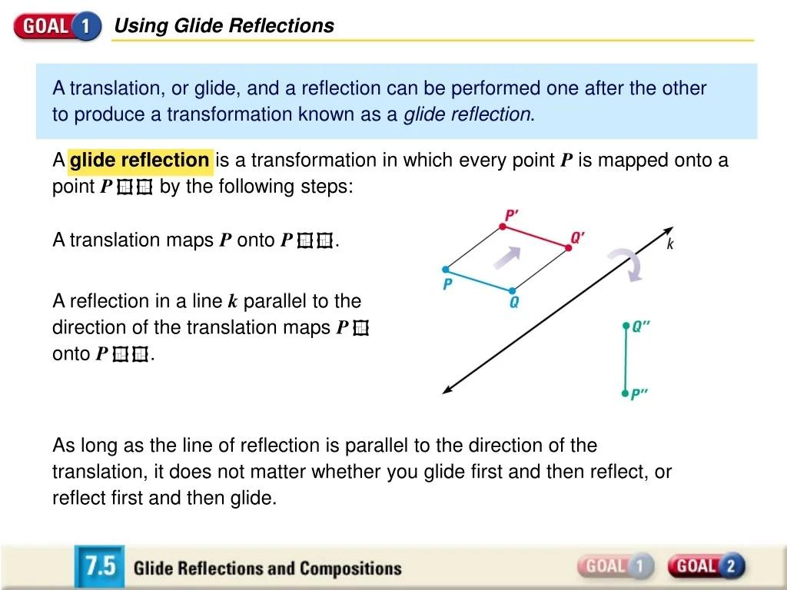
Definition: A glide reflection combines a reflection across an axis with a translation parallel to that same axis.
For reflection across the $x$-axis followed by horizontal translation $a$:
$$\boxed{\left(x , y\right)→\left(x , +a-y\right)}$$
Example: Let $P=\left(2 , 1\right)$and $a=3$.
First reflect:
$$\left(2 , 1\right)→\left(2 , -1\right)$$
Then translate 3 units to the right:
$$\boxed{P^{'}=\left(5 , -1\right)}$$
Properties:
- Combines reflection and translation.
- Preserves lengths and angles.
- Preserves parallelism.
- Reverses orientation.

Axial Symmetry Transformation
# Source: AI Source: Provided by: [Data Path: Persons Table -> ID Column: 1, Name_En Column: Motasem Essam] -> From: [ChatGPT] on [7/25/2026]
Definition: Axial symmetry is reflectional symmetry across a line. A figure has axial symmetry if reflecting it across that axis leaves the figure unchanged.
If $R_{l}$denotes reflection across line $l$, then:
$$\boxed{R_{l}\left(F\right)=F}$$
where $F$is the figure.
Example: A square has four reflection axes:
- Two lines through the midpoints of opposite sides.
- Two lines along its diagonals.
Reflecting the square across any of these axes maps it onto itself.
Properties:
- The axis remains fixed.
- Corresponding points are equally distant from the axis.
- The transformation preserves lengths and angles.
Distinction: Reflection is the transformation; axial symmetry is the property a figure possesses when the reflection leaves it unchanged.

Coordinate-Axis Reflection
# Source: AI Source: Provided by: [Data Path: Persons Table -> ID Column: 1, Name_En Column: Motasem Essam] -> From: [ChatGPT] on [7/25/2026]
This is a specific type of reflection in a coordinate system.
Across the $x$-axis
$$\left(x , y\right)→\left(x , -y\right)$$
Across the $y$-axis
$$\left(x , y\right)→\left(- , xy\right)$$
Across the $z$-axis in three dimensions
$$\left(x , y , z\right)→\left(- , x , -yz\right)$$
The last mapping is reflection across the $xy$-plane, not the $z$-axis. For clarity, a true reflection across the $z$-axis as a line is equivalent to a ${180}^{∘}$rotation around that axis in three-dimensional space only if the transformation is a half-turn, not a plane reflection.
For reflection across the $xy$-plane:
$$\boxed{\left(x , y , z\right)→\left(x , y , -z\right)}$$
This distinction matters because a line is an axis, while a plane is a reflection plane in three-dimensional geometry.

Rotation About a Coordinate Axis
# Source: AI Source: Provided by: [Data Path: Persons Table -> ID Column: 1, Name_En Column: Motasem Essam] -> From: [ChatGPT] on [7/25/2026]
Rotations can be defined about any of the three coordinate axes.
About the $x$-axis
$$\begin{aligned}x^{'}&=x \\ y^{'}&=y\cos{θ}-z\sin{θ} \\ z^{'}&=y\sin{θ}+z\cos{θ}\end{aligned}$$
About the $y$-axis
$$\begin{aligned}x^{'}&=x\cos{θ}+z\sin{θ} \\ y^{'}&=y \\ z^{'}&=-x\sin{θ}+z\cos{θ}\end{aligned}$$
About the $z$-axis
$$\begin{aligned}x^{'}&=x\cos{θ}-y\sin{θ} \\ y^{'}&=x\sin{θ}+y\cos{θ} \\ z^{'}&=z\end{aligned}$$
Example: A ${90}^{∘}$rotation around the $z$-axis maps:
$$\boxed{\left(x , y , z\right)→\left(- , y , xz\right)}$$
The $z$-coordinate stays unchanged because the point rotates around the $z$-axis.

Rotation About an Arbitrary Axis
# Source: AI Source: Provided by: [Data Path: Persons Table -> ID Column: 1, Name_En Column: Motasem Essam] -> From: [ChatGPT] on [7/25/2026]
Definition: A rotation about an arbitrary axis turns a three-dimensional object around any specified line, not necessarily a coordinate axis.
The axis can be defined by:
- A point on the axis, $C$.
- A unit direction vector, $u$.
- A rotation angle, $θ$.
A general vector formula is:
$$\boxed{P^{'}=C+R_{u,θ}\left(P-C\right)}$$
where $R_{u,θ}$is the three-dimensional rotation operator around direction $u$.
Example: A wheel rotates around its axle even when the axle is tilted relative to the coordinate axes.
The axle is the fixed rotation axis.

Half-Turn About an Axis
# Source: AI Source: Provided by: [Data Path: Persons Table -> ID Column: 1, Name_En Column: Motasem Essam] -> From: [ChatGPT] on [7/25/2026]
A half-turn is a rotation of:
$$θ={180}^{∘}$$
about a fixed axis.
For rotation around the $z$-axis:
$$\boxed{\left(x , y , z\right)→\left(- , x , -yz\right)}$$
Example:
$$\left(2 , 3 , 4\right)→\left(- , 2 , -34\right)$$
The point's height remains unchanged, while its position around the axis moves to the opposite side.
Important distinction: A half-turn about an axis in 3D is not generally the same as reflection across a plane.

Composite Axis-Based Transformation
# Source: AI Source: Provided by: [Data Path: Persons Table -> ID Column: 1, Name_En Column: Motasem Essam] -> From: [ChatGPT] on [7/25/2026]
Definition: A composite axis-based transformation combines two or more transformations defined relative to an axis.
For example, a rotation followed by a translation along the same axis can be represented as:
$$T=T_{\text{translation}}∘R_{\text{axis},θ}$$
Example: A screw-like movement combines:
- Rotation around an axis.
- Translation parallel to that axis.
When the translation and rotation occur together, the resulting motion is called a screw motion.
A screw motion is not a pure rotation because points generally move along the axis as well as around it.

Inverse Axis-Based Transformation
# Source: AI Source: Provided by: [Data Path: Persons Table -> ID Column: 1, Name_En Column: Motasem Essam] -> From: [ChatGPT] on [7/25/2026]
An inverse transformation reverses the original operation.
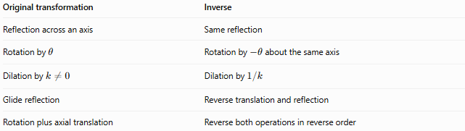
Original transformation | Inverse
Reflection across an axis | Same reflection
Rotation by $θ$ | Rotation by $-θ$about the same axis
Dilation by $k≠0$ | Dilation by $1/k$
Glide reflection | Reverse translation and reflection
Rotation plus axial translation | Reverse both operations in reverse order
For a rotation:
$$\boxed{R_{\text{axis},θ}^{-1}=R_{\text{axis},-θ}}$$
For a composition:
$$\boxed{{\left(T_{2}∘T_{1}\right)}^{-1}=T_{1}^{-1}∘T_{2}^{-1}}$$

Comparison of Axis-Based Transformations
# Source: AI Source: Provided by: [Data Path: Persons Table -> ID Column: 1, Name_En Column: Motasem Essam] -> From: [ChatGPT] on [7/25/2026]
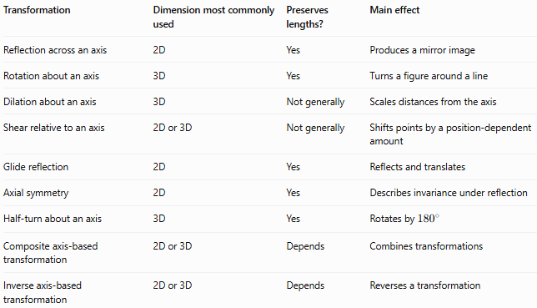
Transformation | Dimension most commonly used | Preserves lengths? | Main effect
Reflection across an axis | 2D | Yes | Produces a mirror image
Rotation about an axis | 3D | Yes | Turns a figure around a line
Dilation about an axis | 3D | Not generally | Scales distances from the axis
Shear relative to an axis | 2D or 3D | Not generally | Shifts points by a position-dependent amount
Glide reflection | 2D | Yes | Reflects and translates
Axial symmetry | 2D | Yes | Describes invariance under reflection
Half-turn about an axis | 3D | Yes | Rotates by ${180}^{∘}$
Composite axis-based transformation | 2D or 3D | Depends | Combines transformations
Inverse axis-based transformation | 2D or 3D | Depends | Reverses a transformation

Key Formulas
# Source: AI Source: Provided by: [Data Path: Persons Table -> ID Column: 1, Name_En Column: Motasem Essam] -> From: [ChatGPT] on [7/25/2026]
Reflection across the $x$-axis:
$$\boxed{\left(x , y\right)→\left(x , -y\right)}$$
Reflection across the $y$-axis:
$$\boxed{\left(x , y\right)→\left(- , xy\right)}$$
Rotation around the $z$-axis:
$$\boxed{\begin{aligned}x^{'}&=x\cos{θ}-y\sin{θ} \\ y^{'}&=x\sin{θ}+y\cos{θ} \\ z^{'}&=z\end{aligned}}$$
Dilation relative to the $x$-axis:
$$\boxed{\left(x , y , z\right)→\left(x , k , ykz\right)}$$
Horizontal shear:
$$\boxed{\left(x , y\right)→\left(x , +kyy\right)}$$
Glide reflection:
$$\boxed{\left(x , y\right)→\left(x , +a-y\right)}$$
General rotation around an arbitrary axis:
$$\boxed{P^{'}=C+R_{u,θ}\left(P-C\right)}$$

Key Points
# Source: AI Source: Provided by: [Data Path: Persons Table -> ID Column: 1, Name_En Column: Motasem Essam] -> From: [ChatGPT] on [7/25/2026]
- An axis is a fixed line used as the reference for a transformation.
- Reflection across an axis is common in plane geometry.
- Rotation about an axis is a fundamental three-dimensional transformation.
- Dilation and shear relative to an axis are useful descriptive forms, but they are not usually grouped as one universal standard taxonomy.
- Reflection preserves lengths and angles but reverses orientation.
- Rotation preserves lengths and angles.
- General dilation and shear do not necessarily preserve lengths or angles.
- Axial symmetry describes a figure's invariance under reflection.
- A line used as an axis should not be confused with a plane used as a reflection plane.
- Inverse transformations reverse the original operation.

Conclusion
# Source: AI Source: Provided by: [Data Path: Persons Table -> ID Column: 1, Name_En Column: Motasem Essam] -> From: [ChatGPT] on [7/25/2026]
Transformation About an Axis is a broad category of geometric transformations defined relative to a fixed line. Its most important examples are reflection across an axis, rotation about an axis, glide reflection, and axial symmetry, with scaling, shearing, and composite operations providing additional axis-relative models.
The central distinction is that reflection uses the axis as a mirror line, while rotation uses it as a line around which points turn.

